**Electrostatic discharge (ESD)**

Electronics are very sensitive to what current they receive sometimes when we repair them we are charged with Static Electricity; we often discharge when we touch a electro-conductive surface. If the surface happens to be a resistor that has bigger resistance then the passed on electric shock.

Static electricity is a reference to a charge that has been built up over time because it has nowhere to go and it cannot move.

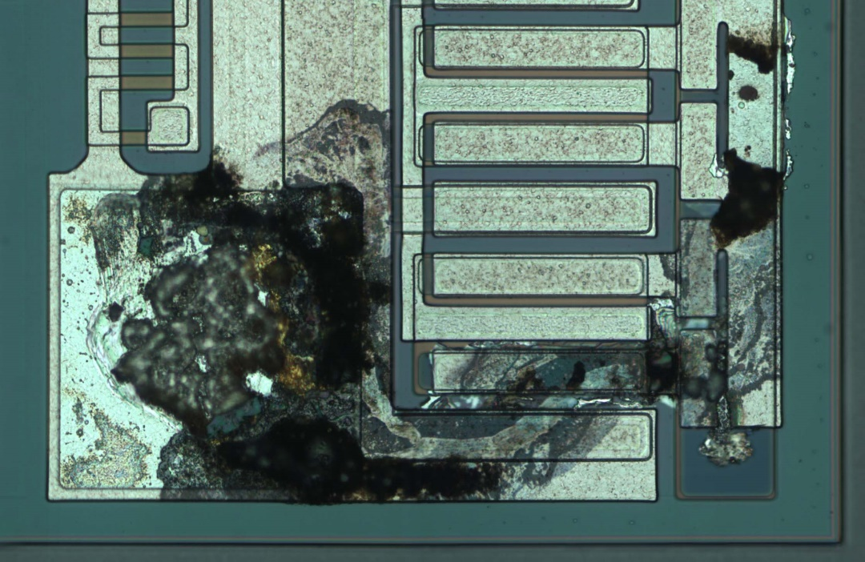

**Prevention**